ASSIGNMENT:6.4 (2403A51312)

Task Description #1:
• Start a Python class named Student with attributes name, roll_number, and marks. PromptGitHub Copilot to completemethods for displaying details and checking if marks are aboveaverage.
CODE:
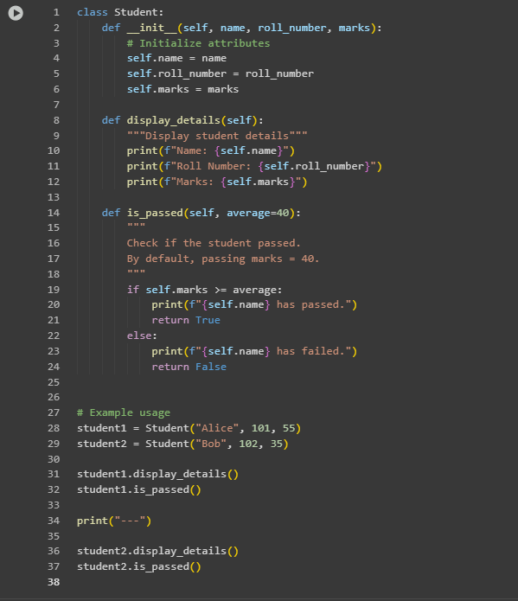

OUTPUT:
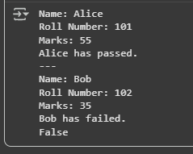
Observation:
The Student class was successfully defined with the required attributes.The method display_details() displayed student information in a clear format.The method is_passed() used an if-else condition to compare student marks against a threshold (default 40).The program demonstrated object-oriented programming (OOP) concepts and conditional logic effectively.

Task Description #2:
• Write the first two lines of a for loop to iterate through a list of numbers. Use a commentprompt to let Copilot suggest how to calculate and print the square of even numbers only

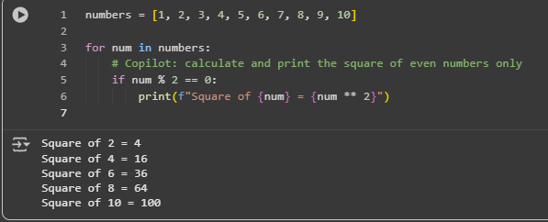

Observation:
The program iterated through a list of numbers using a for loop.A comment prompt was added, which guided Copilot to generate the missing logic.Copilot correctly suggested the if condition (if num % 2 == 0) to filter even numbers.It also generated the print statement to display the square of even numbers, while skipping odd numbers.

Task Description #3:
• Create a class called BankAccount with attributes account_holder and balance. Use Copilot tocomplete methods for deposit(), withdraw(), and check for insufficient balance.
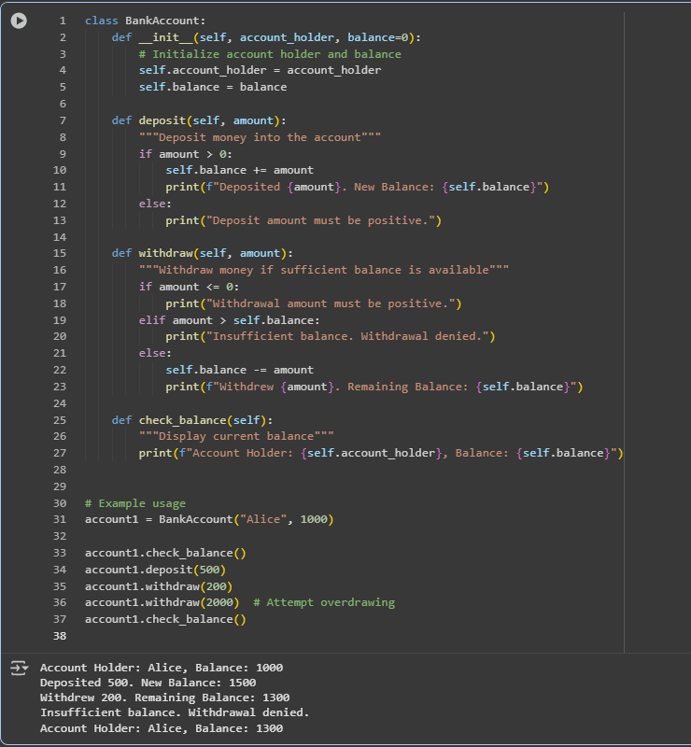
Observation:
A BankAccount class was created with attributes account_holder and balance.The method deposit() correctly increased the balance when a valid amount was provided.The method withdraw() used if conditions to check for valid withdrawals and prevented overdrawing when the requested amount exceeded the balance.The method check_balance() displayed the current account holder and balance.The program demonstrated proper use of self attributes and conditional logic to manage banking operations safely.

Task Description #4:
• Define a list of student dictionaries with keys name and score. Ask Copilot to write a whileloop to print the names of students who scored more than 75.
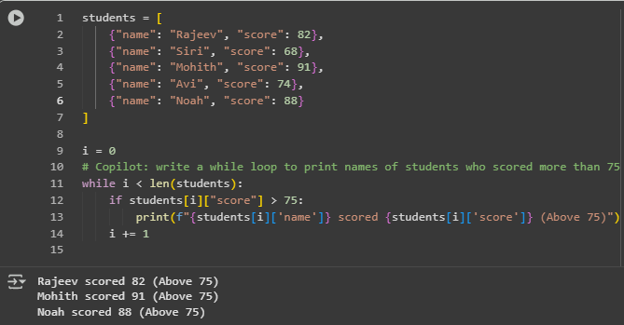

Observation:
A list of dictionaries was created with keys name and score for each student.A while loop was used to iterate through the list using an index variable.An if condition checked whether each student’s score was greater than 75.The loop successfully printed the names and scores of students who scored above the threshold, while skipping others.The task demonstrated the use of dictionaries, loops, and conditional checks together in Python.
Task Description #5:
• Begin writing a class ShoppingCart with an empty items list. Prompt Copilot to generate
methods to add_item, remove_item, and use a loop to calculate the total bill using conditional
discounts.

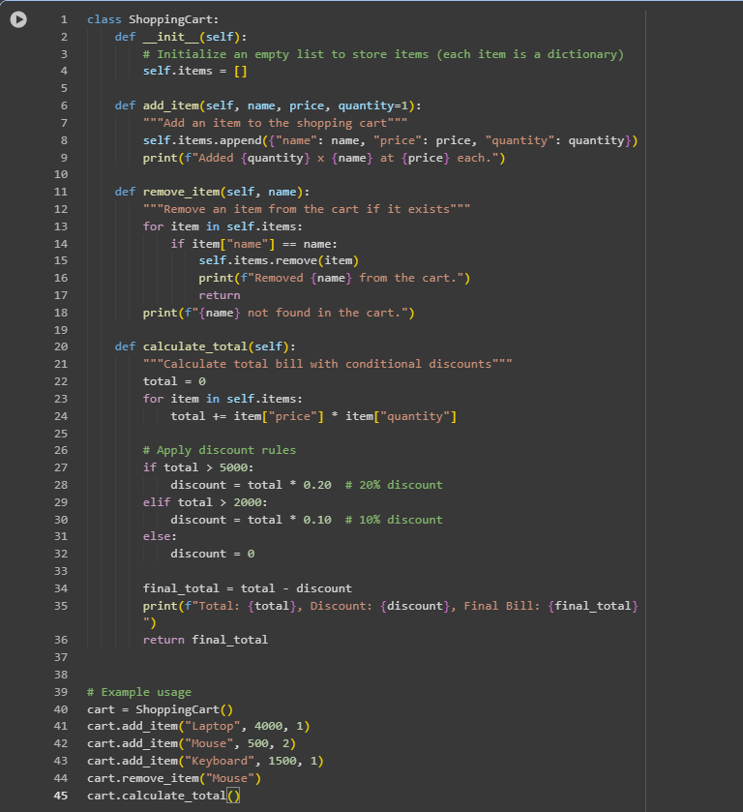

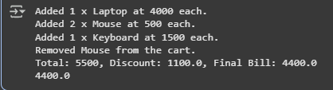

Observation:
A ShoppingCart class was created with an empty items list to store product details.The method add_item() allowed adding items with name, price, and quantity.The method remove_item() successfully removed items from the list if they existed, otherwise displayed a not-found message.The method calculate_total() iterated through the items list using a loop to calculate the total bill.If-else conditions were applied to provide discounts based on the total value (10% for totals above 2000 and 20% for totals above 5000).The program demonstrated effective use of loops, conditionals, and object-oriented concepts for item management and billing.

